**Insert School Logo**

**Semester Two Examination 2018**

**Question/Answer Booklet**

**MATHEMATICS**

**METHODS UNITS 3 & 4**

**Section Two:**

**Calculator-assumed**

Student Name: _____________________________________

Teacher’s Name: _____________________________________

**Time allowed for this section**

Reading time before commencing work: ten minutes

Working time for paper: one hundred minutes

**Material required/recommended for this section**

**To be provided by the supervisor**

This Question/Answer booklet

Formula Sheet (retained from Section One)

**To be provided by the candidate**

Standard items: pens(blue/black preferred), pencils(including coloured), sharpener, correction tape/fluid, erasers, ruler, highlighters

Special Items: drawing instruments, templates, notes on two unfolded sheets of A4 paper, and up to three calculators approved for use in the WACE examinations.

**Important note to candidates**

No other items may be taken into the examination room. It is **your** responsibility to ensure that you do not have any unauthorised notes or other items of a non-personal nature in the examination room. If you have any unauthorised material with you, hand it to the supervisor **before** reading any further.

**Structure of this paper**

|  |  |  |  |  |  |
| --- | --- | --- | --- | --- | --- |
|  | Number of questions available | Number of questions to be attempted | Working time (minutes) | Marks available | Percentage of exam |
| Section One  Calculator—free | **9** | **9** | **50** | **50** | **35** |
| **Section Two**  **Calculator—assumed** | **11** | **11** | **100** | **100** | **65** |
|  | | | |  | 100 |

**Instructions to candidates**

1. The rules for the conduct of Western Australian external examinations are detailed in the *Year 12 Information Handbook 2018.* Sitting this examination implies that you agree to abide by these rules.
2. Answer the questions according to the following instructions.

Section Two: Write answers in this Question/Answer Booklet. Answer **all** questions.

**Show all your working clearly.** Your working should be in sufficient detail to allow your

answers to be checked readily and for marks to be awarded for reasoning. Incorrect

answers given without supporting reasoning cannot be allocated any marks. For any

question or part question worth more than two marks, valid working or justification is required to receive full marks. If you repeat an answer to any question, ensure that you cancel the answer you do not wish to have marked.

It is recommended that you **do not use pencil**, except in diagrams.

1. You must be careful to confine your responses to the specific questions asked and to follow any instructions that are specific to a particular question.
2. Spare pages are included at the end of this booklet. They can be used for planning your responses and/or as additional space if required to continue an answer.

* Planning: If you use the spare pages for planning, indicate this clearly at the top of the page.
* Continuing an answer: If you need to use the space to continue an answer, indicate in the original answer space where the answer is continued, i.e. give the page number. Fill in the number of the question that you are continuing to answer at the top of the page.

1. The Formula Sheet is **not** handed in with your Question/Answer Booklet.

# Section Two: Calculator–Assumed 100 marks

This section has **eleven (11)** questions. Attempt **all** questions. Write your answers in the spaces provided.

Spare pages are included at the end of this booklet. They can be used for planning your responses and/or as additional space if required to continue an answer.

* Planning: If you use the spare pages for planning, indicate this clearly at the top of the page.
* Continuing an answer: If you need to use the space to continue an answer, indicate in the

original answer space where the answer is continued, i.e. give the page number. Fill in the

number of the question(s) that you are continuing to answer at the top of the page.

Working time: 100 minutes

**Question 10 (5 marks)**

The table shows the pdf of a discrete random variable; where E(X) is the expected value of X.

|  |  |  |  |  |  |
| --- | --- | --- | --- | --- | --- |
| x | 1 | 2 | 3 | 4 | 5 |
| P(X = x) | 0.2 | p | 0.3 | q | 0.1 |

**(a)** If E(X2) = 8.2 , determine p and q. (3 marks)

**(b)** Calculate E(X). (1 mark)

**(c)** If Y = 1 − 2X, calculate E(Y). (1 mark)

**Question 11 (12 marks)**

A sample of 200 University students showed that 86 passed all exams in their first year.

**(a)** Calculate the sample proportion. (1 mark)

**(b)** If p is the actual proportion of students passing all their exams in the first year, determine

a 90% confidence interval for p. Show your reasoning clearly. (4 marks)

A different group were surveyed.

They calculated a confidence interval for p to be 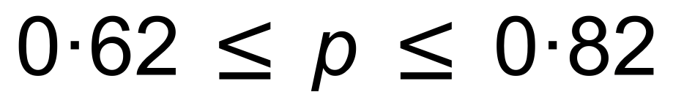.

It was suggested that the two samples were from the same population.

**(c)** Does the evidence support that claim? Show your reasoning clearly. (3 marks)

A subset of ten of those students from University included seven who passed all their exams in their first year.

Four of those ten were chosen at random.

**(d)** (i) Explain why the probability of exactly one of the four chosen having passed all his/her

exams in their first year is not a Binomial question? (1 mark)

(ii) Determine the probability that exactly one of the four chosen passed all exams in

his/her first year. (3 marks)

**Question 12 (10 marks)**

A small business has a daily turnover which is uniformly distributed between $6000 and $10 000.

**(a)** Sketch a graph showing this uniform distribution **and** define it. (2 marks)

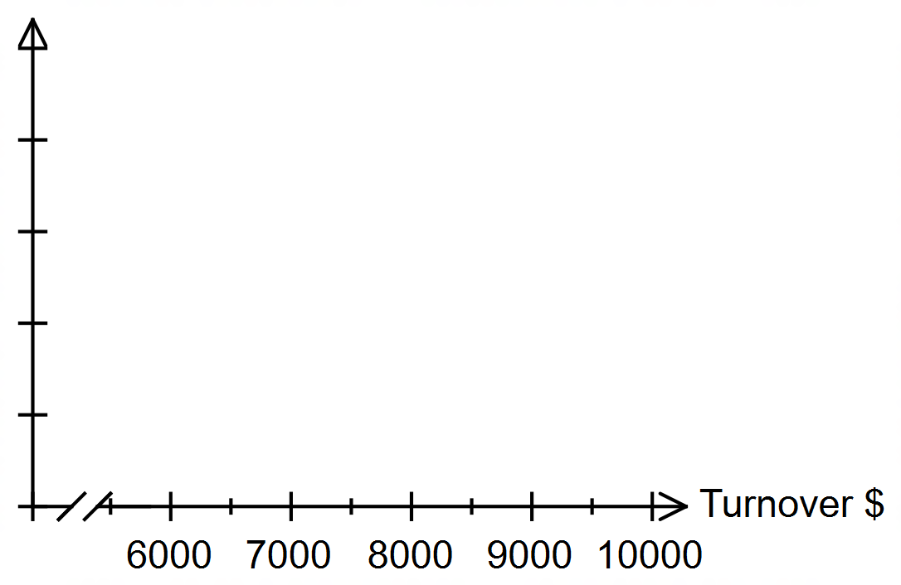

**(b)** What is the probability that on a randomly selected day:

(i) the business turnover is between $8000 and $9000? (1 mark)

(ii) the business turnover is $8500? (1 mark)

**(c)** Calculate the mean turnover, showing any formulae used. (2 marks)

**(d)** (i) Calculate the standard deviation of the business turnovers to the nearest $,

showing any formulae used. (3 marks)

(ii) Another business has a daily turnover uniformly distributed between $6000 + *k*

and $10 000 + *k*. State the standard deviation of its turnover, giving a reason. (1 mark)

**Question 13 (9 marks)**

Consider $1000 growing under compound interest with a continuous growth of 8% pa.

The graph of ln *V* against *t* is shown below, where *V* is the value of the investment after *t* years.

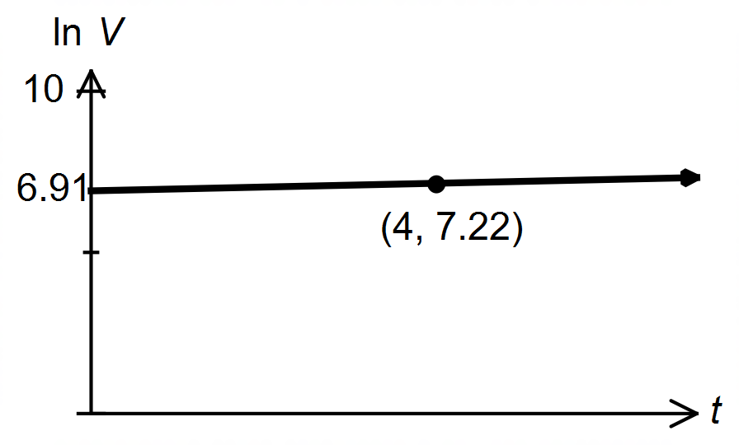

**(a)** State the:

(i) equation of the line. (2 marks)

(ii) exponential relationship between *V* and *t*. (2 marks)

**(b)** Use your answer from **(a)** to determine how long it will take for the investment

to double. (2 marks)

**(c)** If 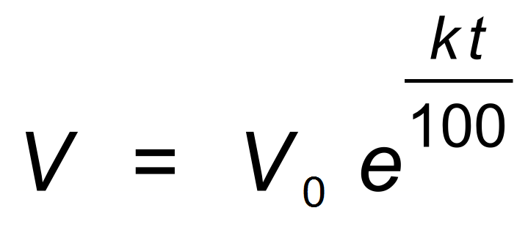 , determine a rule for doubling time.

Your rule is to be of the form 

(Hint: Let 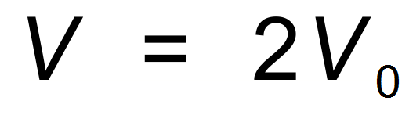) (3 marks)

**Question 14 (12 marks)**

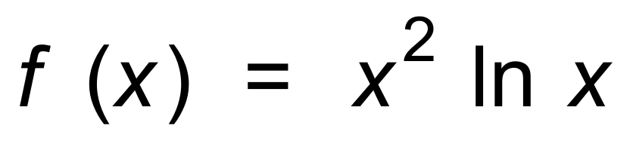

**(a)** Use Calculus to locate and classify all the stationary points of f (x). (5 marks)

**(b)** Use Calculus to determine the coordinates of any points of inflection. (3 marks)

**(c)** Sketch the graph of f (x) over the domain 0 < x ≤ 1.2

Label all the key features of the graph. (4 marks)

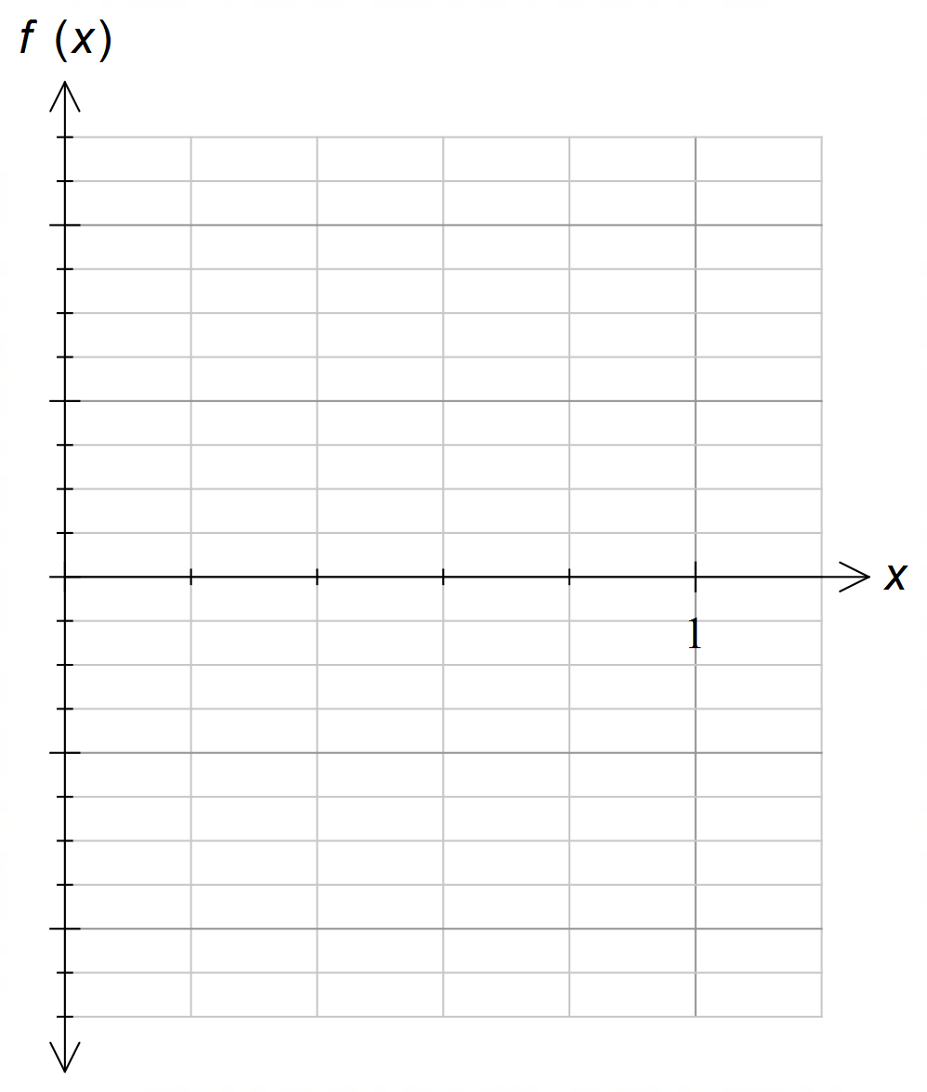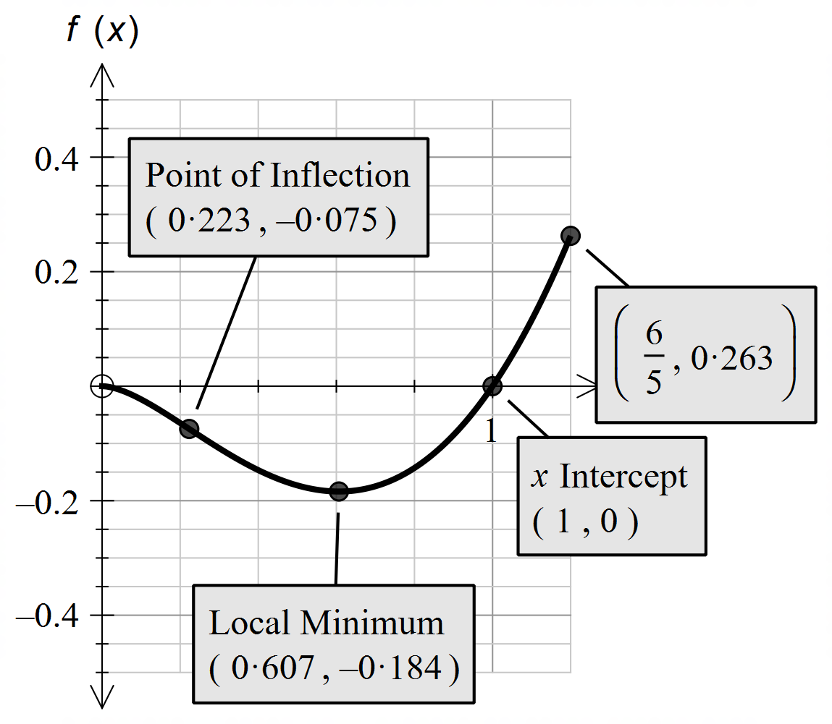

**Question 15 (10 marks)**

The acceleration of an object undergoing rectilinear motion is given by 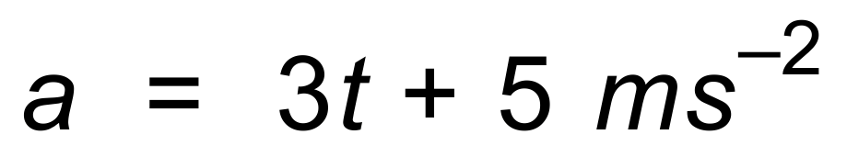.

The object has an initial velocity of 20 m/s and begins its motion at a displacement of −10 m.

**(a)** Determine:

(i) the velocity at *t* = 3 seconds. (3 marks)

(ii) the displacement at *t* = 3 seconds. (3 marks)

**(b)** Show that the object is never at rest. (2 marks)

Hence, or otherwise,

**(c)** determine the distance travelled by the object in the first three seconds. (2 marks)

**Question 16 (7 marks)**

It was found in a particular city that 80% of people had pay TV.

A random sample of 36 adults is taken, with X being the random variable

“the number of people who have pay TV.”

**(a)** Determine P(*X* ≤ 30). (2 marks)

**(b)** For the sampling distribution, 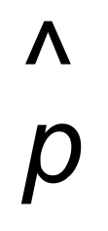:

(i) 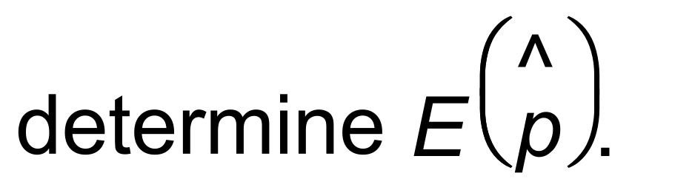 (1 mark)

(ii) 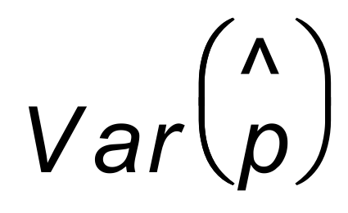. (2 marks)

**(c)**  Determine the probability that if ten random samples of size thirty are selected,

and a 90% confidence interval is calculated, they will all contain the population

mean. (2 marks)

**Question 17 (9 marks)**

A business has many employees. Their ages are shown in the table.

|  |  |  |  |  |
| --- | --- | --- | --- | --- |
| Age Group | 20 − 29 | 30 − 39 | 40 − 49 | 50 − 59 |
| Number of Employees | 727 | 1050 | 800 | 523 |

A sample size of 100 is to be chosen for a staff survey.

**(a)** Describe and calculate how a stratified sample could be collected. (3 marks)

The proportion of employees in the 30 − 39 year age group is 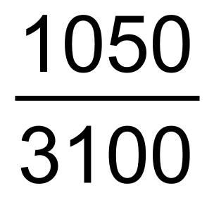 .

(You would have calculated this in **(a)**.)

**(b)** (i) Describe the distribution of sample proportions of the 30 − 39 year age group in

samples of size 100. (1 mark)

(ii) Calculate the mean and standard deviation for the proportions of 30 − 39

year−olds in samples of size 100. (2 marks)

**(c)** In a sample of size 100, find the probability that at least forty are aged between 30 and 39 years. State the distribution you are using. (3 marks)

**Question 18 (7 marks)**

The game of “Unders and Overs” involves rolling two standard six−sided dice.

If the sum of the uppermost faces is seven, the player is returned $12.

**(a)** Find the probability that a score of seven occurs. (1 mark)

If the sum is less than seven, the player is returned $12.

**(b)** Find the probability that a score of less than seven occurs. (1 mark)

If the sum is greater than seven, the player is returned $12.

**(c)** Find the probability that a score of greater than seven occurs. (1 mark)

**(d)** If the game is to be fair, how much should a player pay to play the game? (1 mark)

A sporting Club is keen to raise funds for the purchase of equipment.

It has a night where players pay $5 to play. The returns are shown in the table.

|  |  |  |
| --- | --- | --- |
| Unders | Overs | Sevens |
| $1 | $1 | $20 |

**(e)** Calculate how much profit the Club makes for each roll of the dice. (3 marks)

**Question 19 (11 marks)**

The diagram shows an open box (*no top*) with height *h* cm, length 3*x* cm and width *x* cm.

The volume of the box is fixed at 18 cm3.

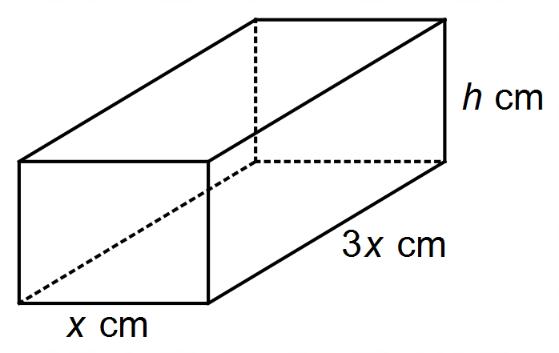

**(a)** Show that the total surface area of the box, *SA*, is given by 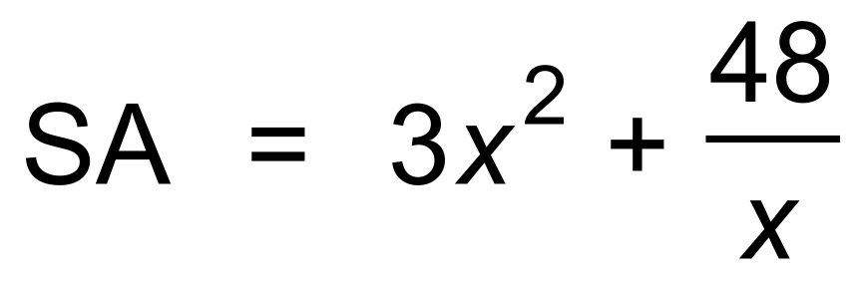 . (3 marks)

**(b)** Find the dimensions which makes the surface area a maximum value,

and state that value. (3 marks)

**(c)** If *x* increases from 2 to 2.1 cm, show why the incremental formula can not be used to approximate the change in surface area. (2 marks)

The rate with which the height changes is 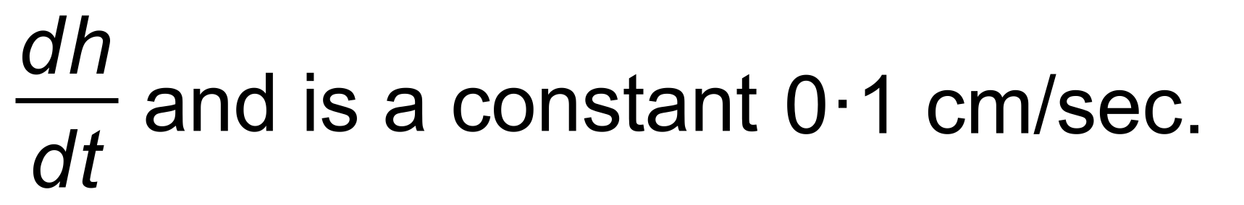

**(d)** Use the chain rule to determine 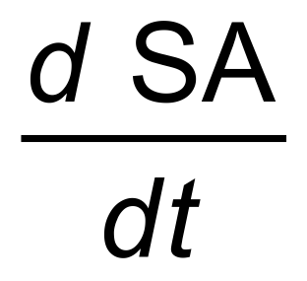 at the instant when *x* = 1 cm.

(Hint: 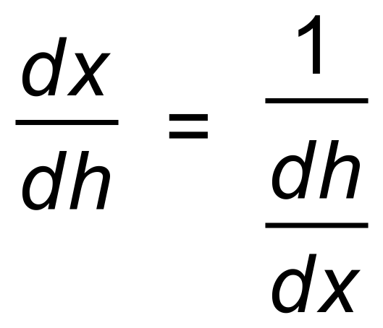 ) (3 marks)

**Question 20 (8 marks)**

In Northtown, the heights, in metres, of the town’s people are normally distributed with a

mean of 1.6 and variance of 0.16

**(a)** Determine the probability that a randomly selected person is taller than 2 metres. (2 marks)

**(b)** Determine the 0.9 quantile. (2 marks)

Four people are randomly selected from the town.

**(c)** Calculate the probability that:

(i) exactly one is taller than 2 metres. (2 marks)

(ii) exactly one is taller than 2 metres and the other three are shorter

than 1.6 metres. (2 marks)

**END OF QUESTIONS**

**Additional working space**

Question number(s): ……………………